**ASSIGNMENT NO:1**

**TOPIC :** Make a Smart Home in Tinker cad, using 2+ sensors,

LED, Buzzer in single code and circuit

**BATCH NO :**B3-3M5E

**TEAM ID :** PNT2022TMID33556

**TEAM LEADER :** NAGENTHIRAN M

**CIRCUIT DIAGRAM:**

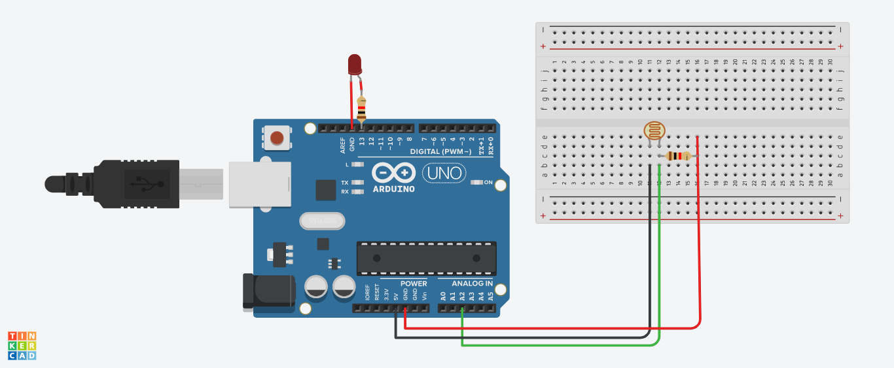

**CODE :**

const int ledpin = 13;

const int lightpin = A2;

const int LIGHT = 10;

void setup() {

Serial.begin(9600);

pinMode(ledpin, OUTPUT);

pinMode(lightpin, INPUT);

}

void loop() {

int lightsens = analogRead(lightpin);

if (lightsens < LIGHT) {

digitalWrite(ledpin, HIGH);

delay(1500);

}

else {

digitalWrite(ledpin, LOW);

}

}

**AFTER SIMULATION:**

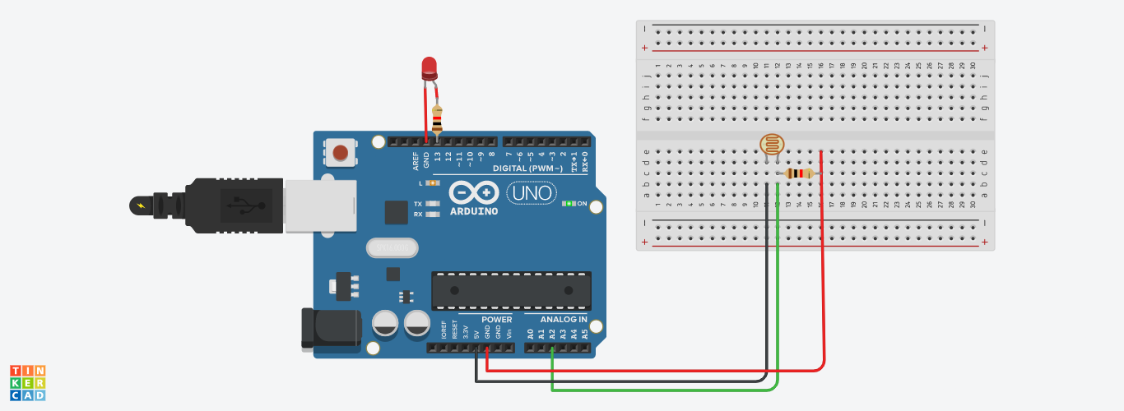

**CONCLUSION:**

Here I designed the automatic light turn on circuit when the intensity of light decreases using Arduino UNO.